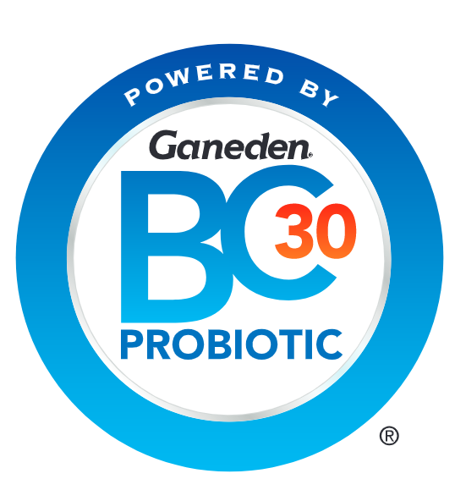

**GanedenBC30®: Approval in Brazil creates new**

**probiotic market opportunities**

**Beloit, WI – November 11, 2020**

Regulators in Brazil have approved a health claim for leading probiotic Ganeden**BC30®**, creating new opportunities to meet growing demand for products with digestive health benefits.

The Brazilian market offers significant potential to manufacturers fortifying foods and beverages with probiotics. For example, a survey of 800 Brazilian consumers in 2019 found that half (49%) had either used products with beneficial bacteria, like probiotics, over the past six months or would consider doing so.*

Ganeden**BC30** (*Bacillus coagulans* GBI-30, 6086) is a spore-forming probiotic ingredient backed by over 25 published papers. This robust research portfolio enabled Kerry (the makers of Ganeden**BC30**) to submit claims approval documentation to ANVISA, the Brazilian agency responsible for the regulation of food and supplements.

The claim subsequently approved by ANVISA is “*Bacillus coagulans*GBI-30, 6086 can contribute to the health of the gastrointestinal tract.” It is approved for use in conventional food and beverage categories for children over three years and adults. In order to be marketed and sold in Brazil, all finished products containing Ganeden**BC30** must carry the new claim, register their product separately with ANVISA, and include all required disclaimer statements on packaging.

Kerry’s 2019 research also found that consumers in Brazil recognized the benefits of the Ganeden**BC30** brand,and that its claims resonated. When presented with images of products featuring the Ganeden**BC30** logo, 55% of Brazilian consumers correctly perceived that it can promote good digestive health. When given a product description, 91% agreed that it was either “completely believable,” or “somewhat believable.” Nine in ten stated they were likely to buy products containing Ganeden**BC30**.

John Quilter, VP & General Manager for Ganeden**BC30**, said: “Consumers in Brazil are very interested in functional foods and beverages with digestive health benefits, and aware that probiotics can provide them. Our consumer research also shows a high demand for products backed by science, which Ganeden**BC30** can meet. The volume and quality of evidence supporting its efficacy enabled us to provide the Brazilian authorities with a robust scientific dossier, along with clinical studies.”

He added: “As a company committed to research and global growth, we’re delighted that this has resulted in new opportunities for manufacturers. First, brands can offer their consumers a high-quality, science-backed probiotic in an important market. Second, they can leverage the Ganeden**BC30** brand to differentiate their products and communicate real benefits to consumers.”

Ganeden**BC30** is a hardy spore-forming probiotic, which means it can thrive in processing conditions other strains cannot. It can survive better in most food and beverage applications, including the products consumers in Brazil are most interested in purchasing. These include yogurts, juices, cereals, breakfast bars and snacks with digestive health benefits.

* Kerry Global Consumer Research for Wellmune® and Ganeden**BC30**, Brazil Report, June 2019

**About** **GanedenBC30®** 

Ganeden**BC30**® (*Bacillus coagulans*GBI-30, 6086) is a patented, FDA GRAS probiotic ingredient found in more than 1,000 leading food and beverage products around the world. It is a shelf-stable, science-backed probiotic strain that has been shown to provide digestive health, immune health and protein utilization benefits. Unlike most other probiotic strains, Ganeden**BC30** is a spore-former, which makes it highly stable and allows it to remain viable throughout most manufacturing processes and the low pH of stomach acid. Well-researched and easy to formulate into functional food, beverages and companion animal products, Ganeden**BC30** is backed by over 25 published papers. Part of Kerry’s ProActive Health portfolio, Ganeden**BC30** is natural, and available in vegan, non-GMO Project-verified, organic-compliant and allergen-free versions.

For more information, please visit: [BC30Probiotic.com](http://bc30probiotic.com/)

**Contact:**   
Molly Fitzgerald

Digital Marketing Communications – Kerry

+1 (612) 309-6792

[molly.fitzgerald@kerry.com](mailto:molly.fitzgerald@kerry.com)